Tin 6
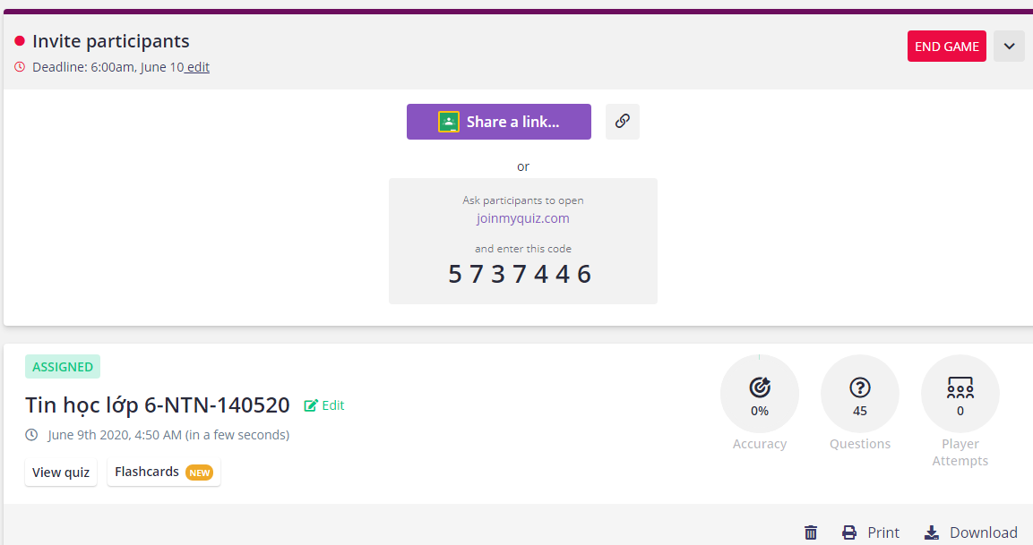
Tin 7
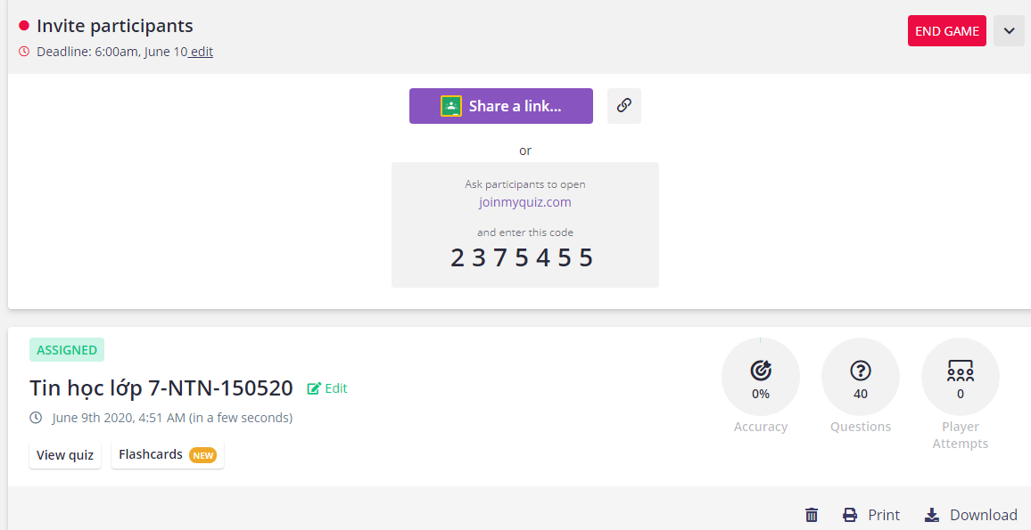
Tin 10
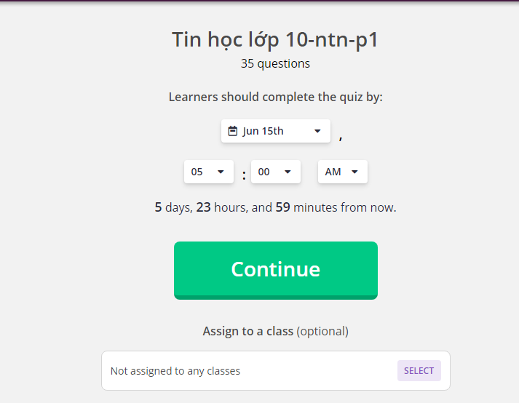
Link 10
Tin 10 https://forms.gle/XUERhBsvZD6mLENk8
Tin 6: https://forms.gle/SyhJofU4rYS1zkzJ8
Tin 7: https://forms.gle/ViPR3xinmuSh64Bs6

